**Data Flow Diagram**

**Group Members:**

Aditya Srivastava (1910110034)

Akansh Mittal (1910110039)

Prabhat Kumar Singh Gaur (1910110272)

**Project Title:** OrphanAide

**Level 0:**

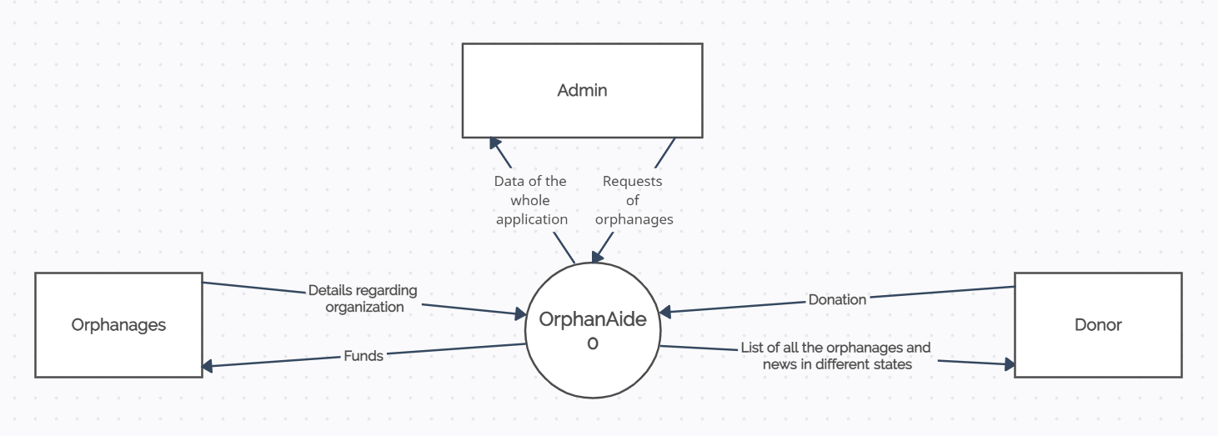

**Level 1:**

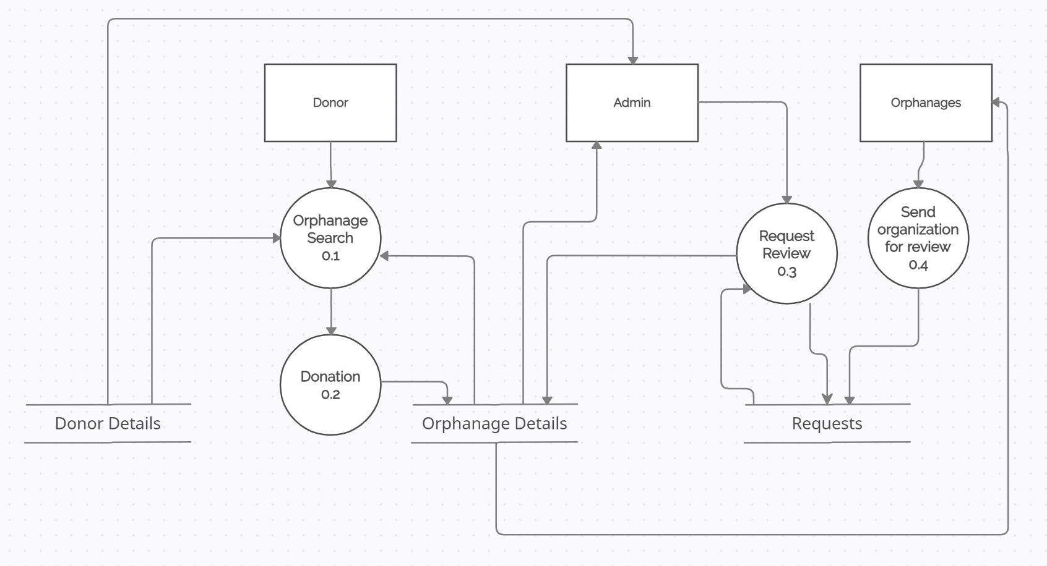

**Level 2:**

